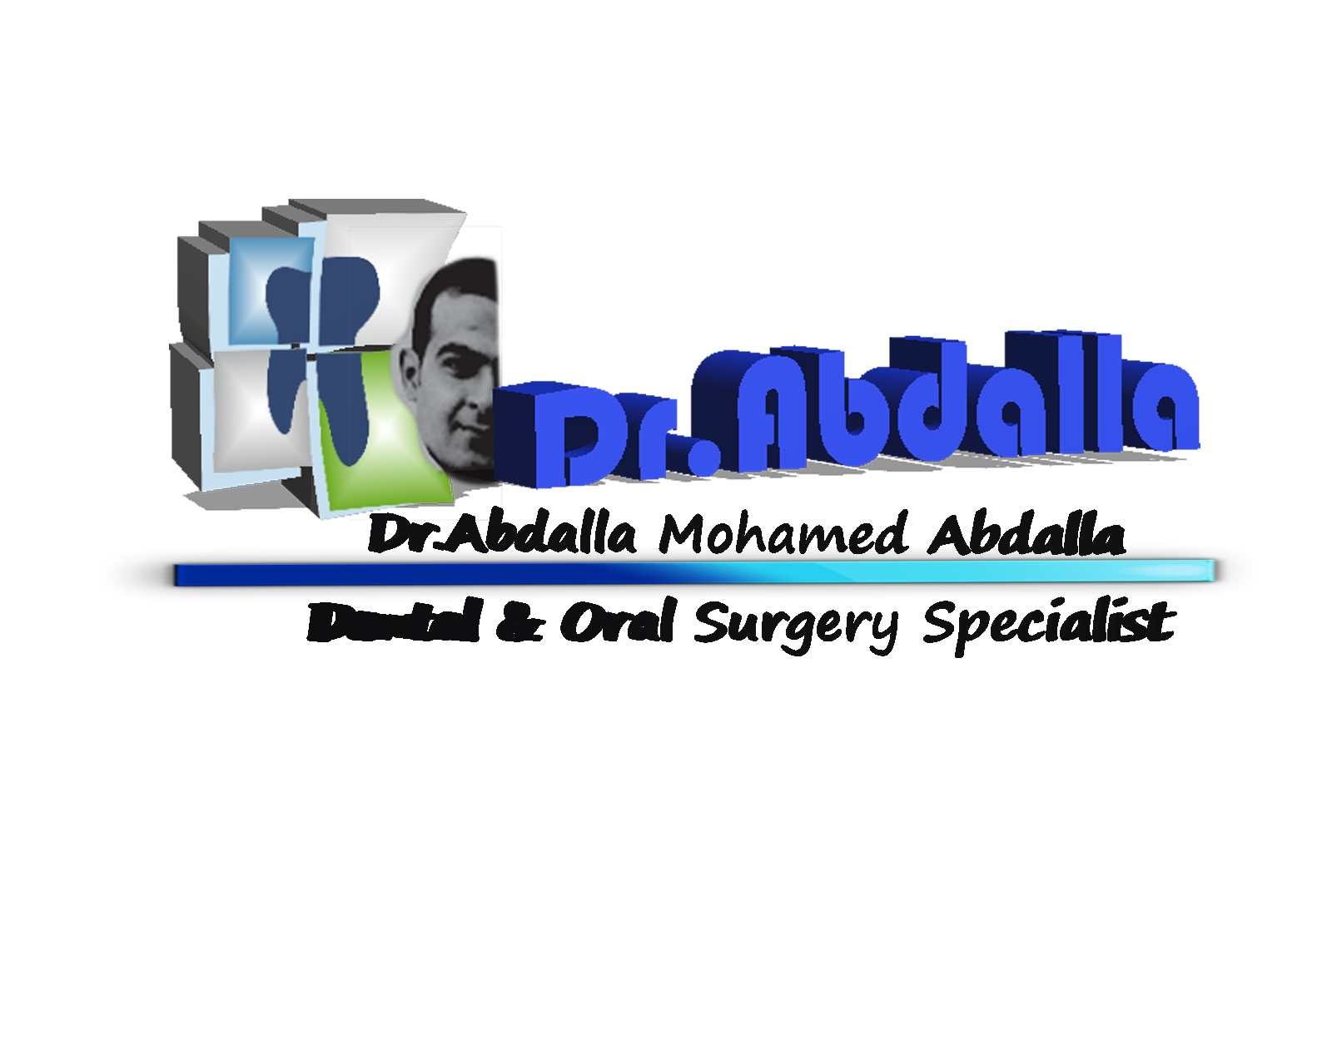
Curriculum Vitae
Personal information:

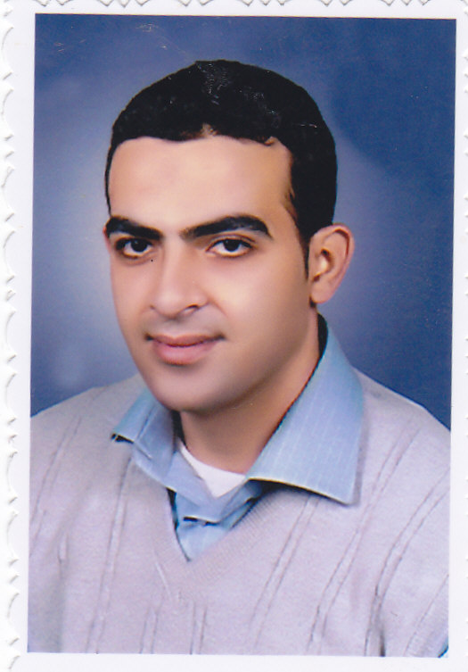
Name : Dr. ABDALLA MOHAMED ABDALLA
Job : Dentist
Nationality : Egyptian
Date of birth : 27/07/1980
Place of birth : EGYPT
Martial status : MARRIED
Address : (RIYADH –SAUDI ARABIA).
Mobile : 00966583344782
Email : bidobido55@YAHOO.COM.

Faculty information:

University : Alexandria - Egypt
Faculty : Faculty of DENTISRY
Department : ORAL MEDICINE AND SUERGERY
Graduation Degree : BSc Degree of ORAL MEDICINE AND SUERGERY.
Graduation Year : May 2002.
POST Graduation : DIPLOMA OF ORAL SUERGERY 2007.
Saudi Commission for Health Specialties: Available from 2009 TO 2016.

Experience:

Working as dentist in Egyptian ministry of health for 10 years.

1-

Working as a surgeon in university of Alexandria .

2-

Working as a dentist in elzeewyed health group in KSA for 5 years .

3-

Current Job

(AJAJY MEDICAL CENTER) – RIYADH -KSA

